# **Tech Conference Website Documentation**

## **For Large Size Screens:**

## **Home Page:**

When the “Register Now” button is clicked.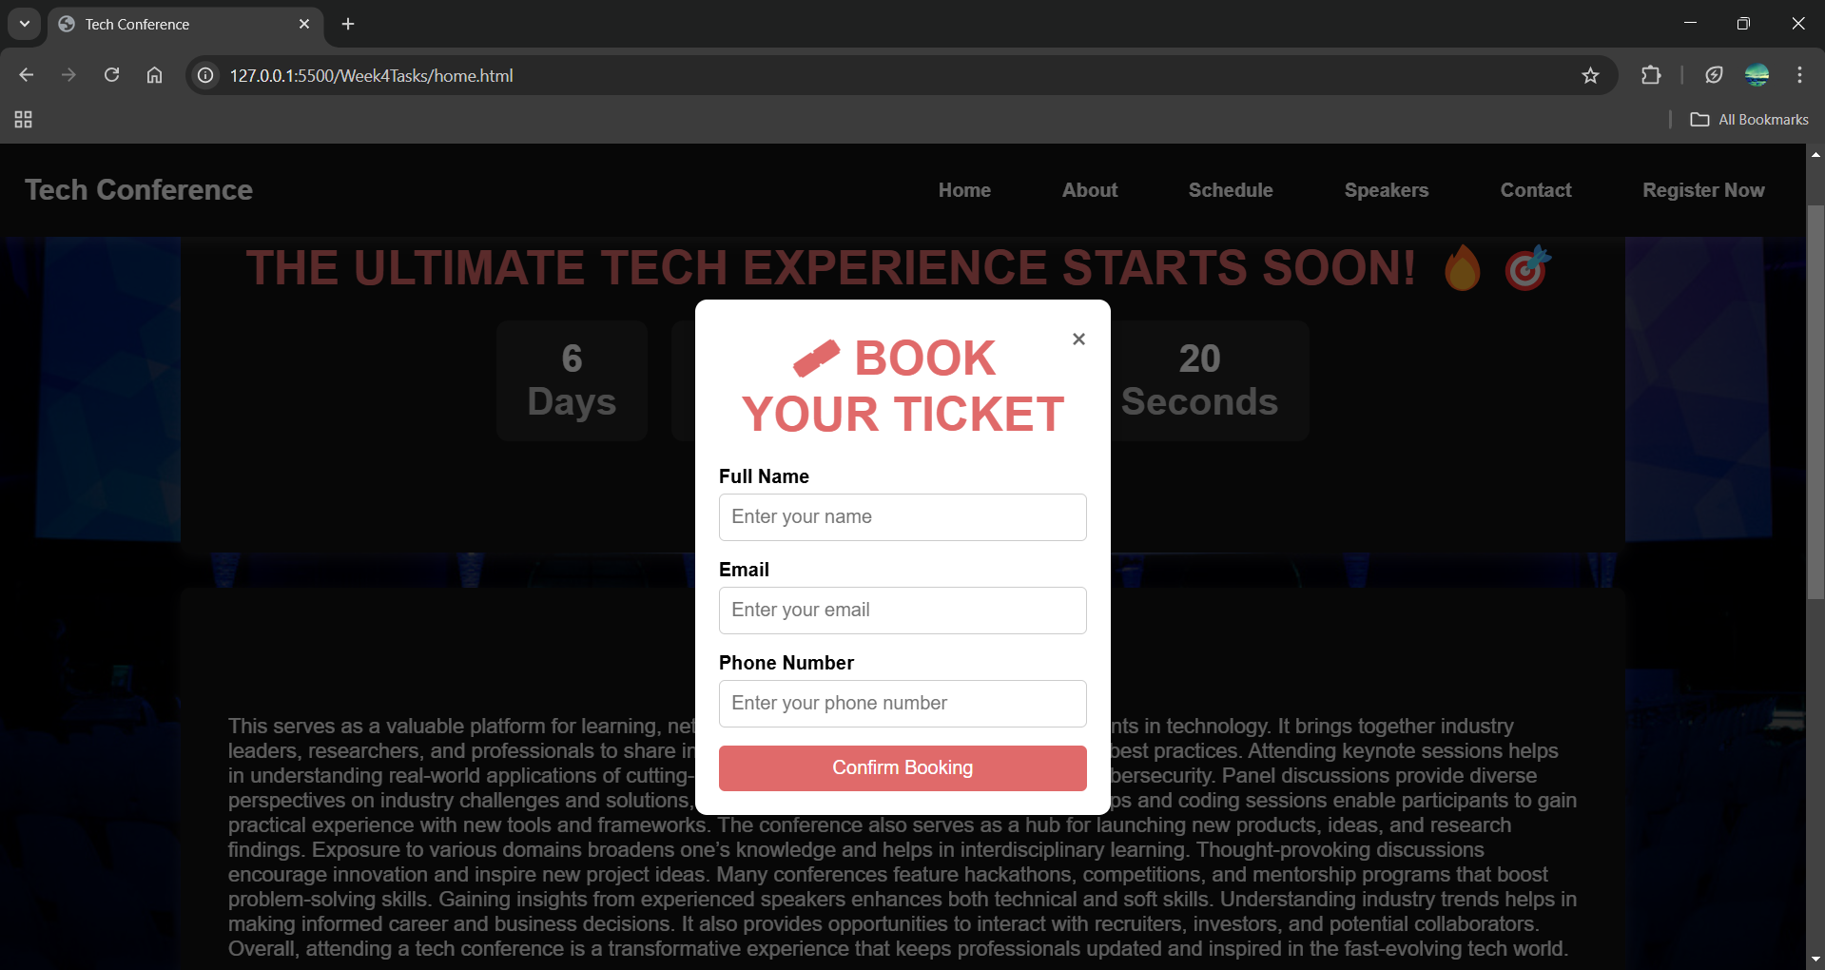

The “Confirm Booking” button can be clicked only when Full Name,Email and Phone Number input fields are filled by the user.And it also validates the input datatype formats.

**About Page:**

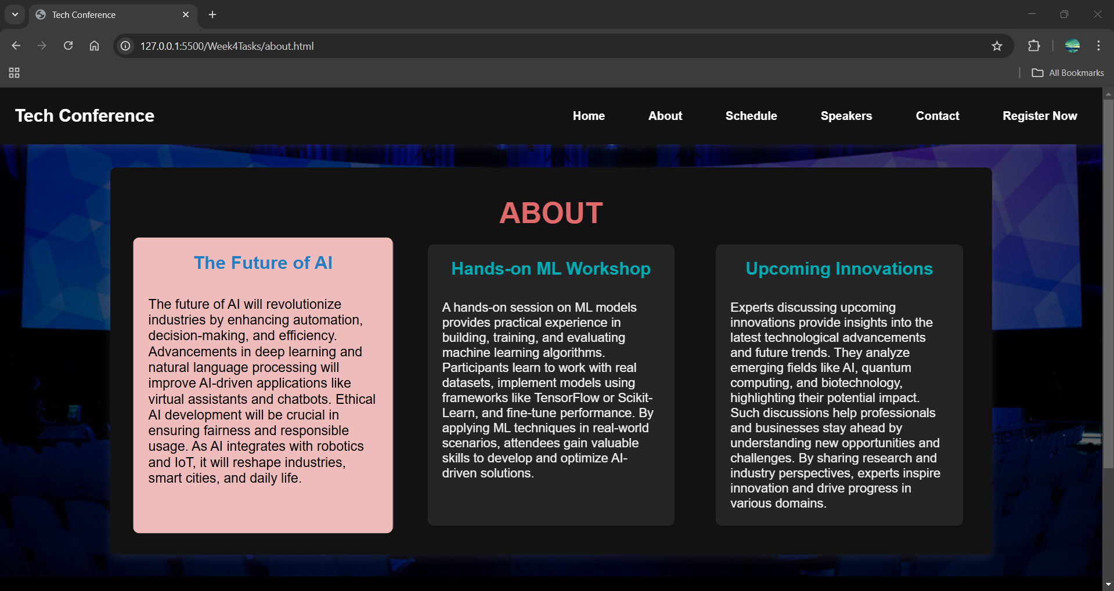

**Schedule Page:**

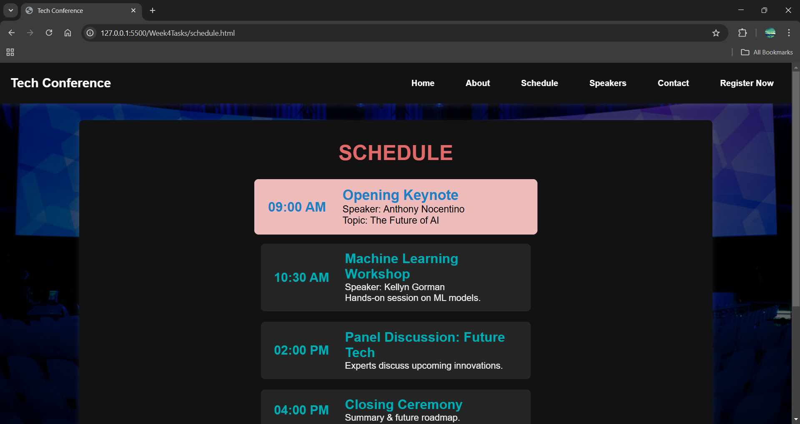

**Speakers Page:**

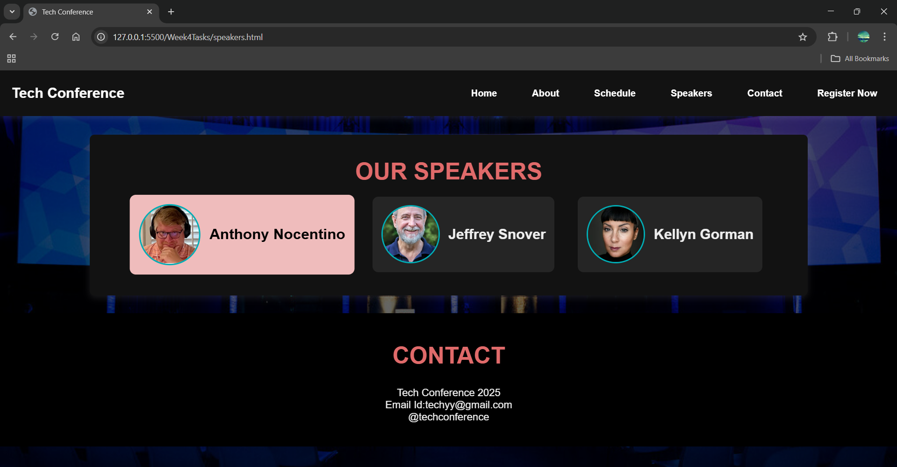

Users can view details of a specific speaker by clicking on the speaker's name.

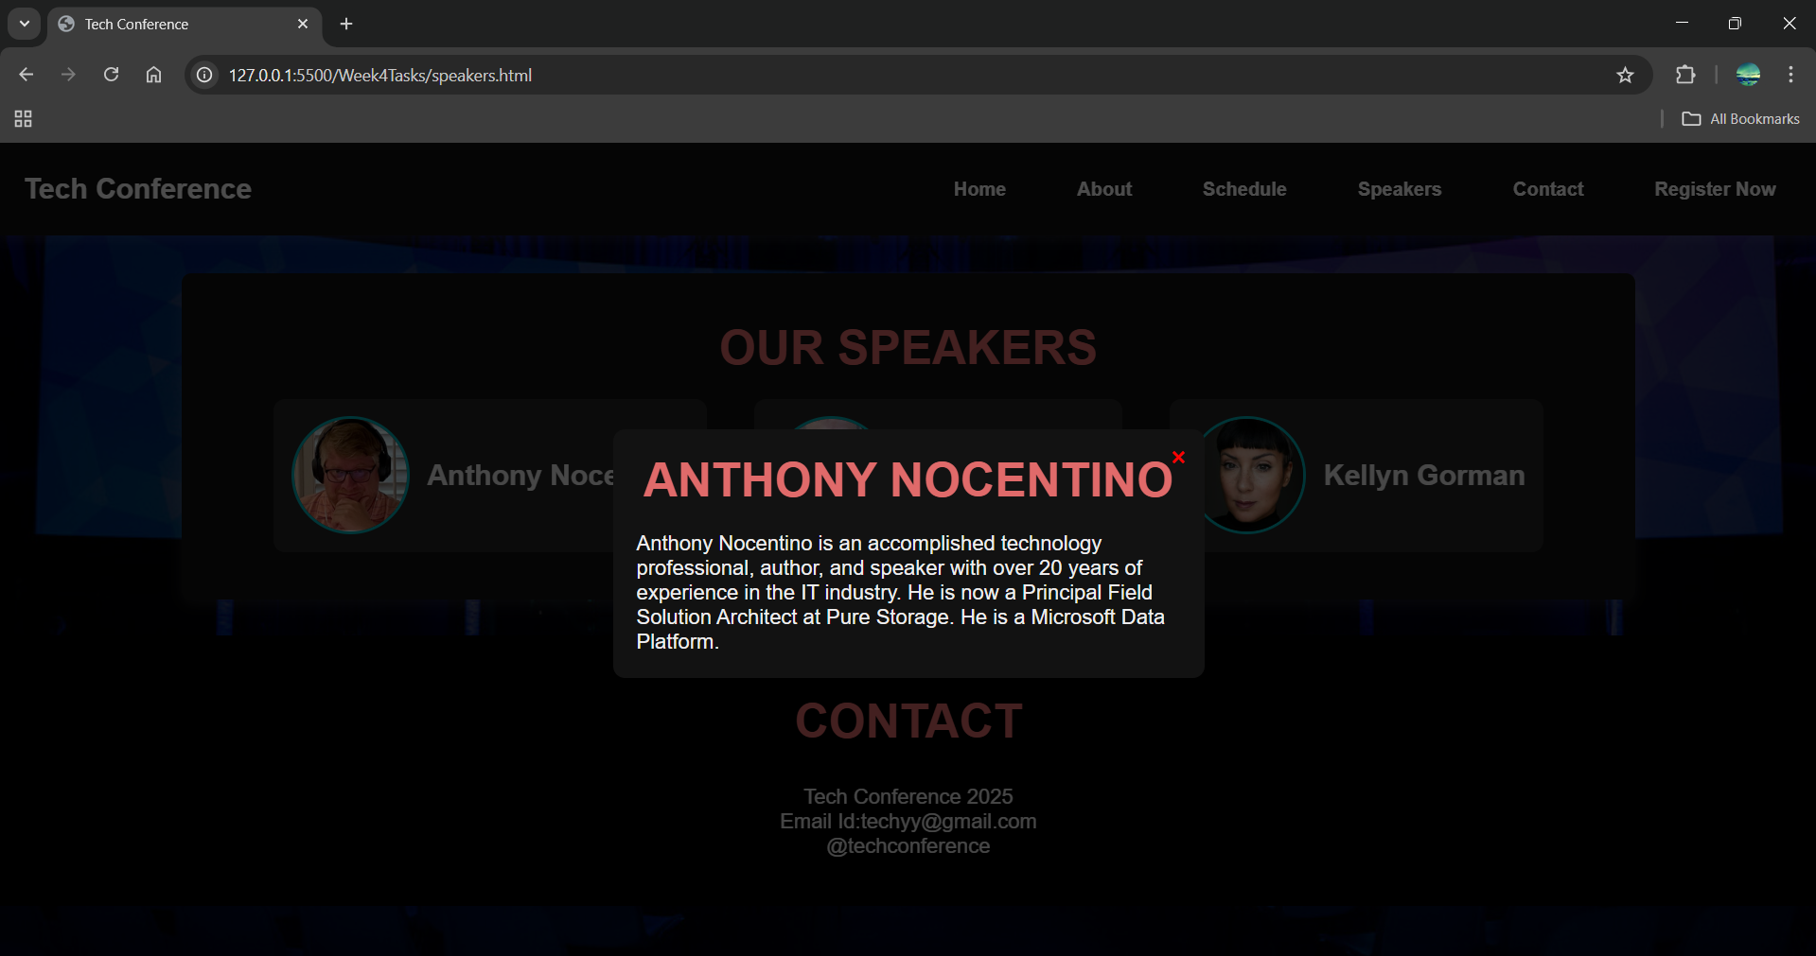

## **For Mobile Size Screens:**

**Home Page:**

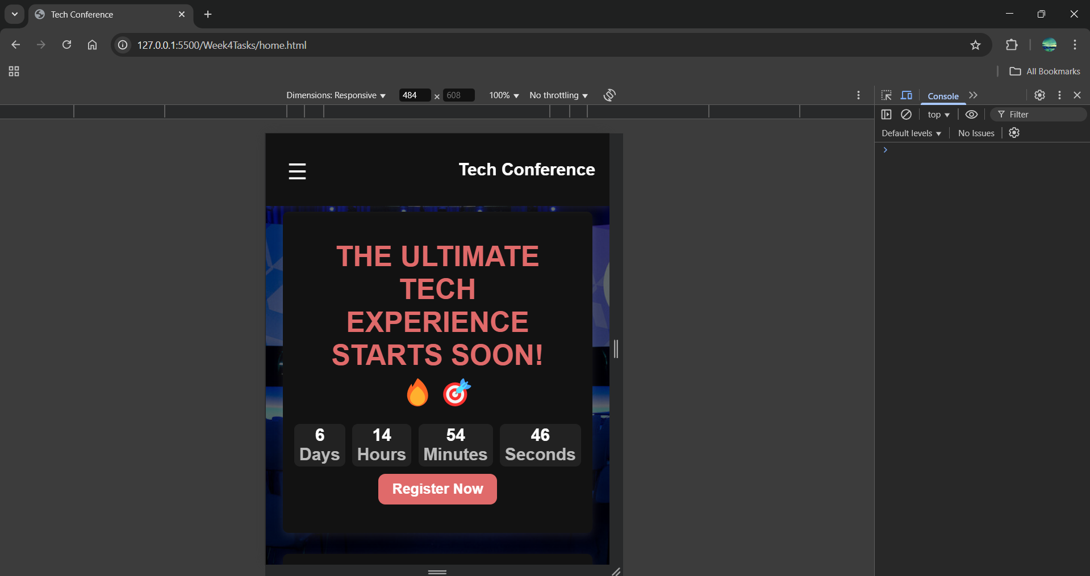

Users can open and close the menu bar by clicking the menu icon.

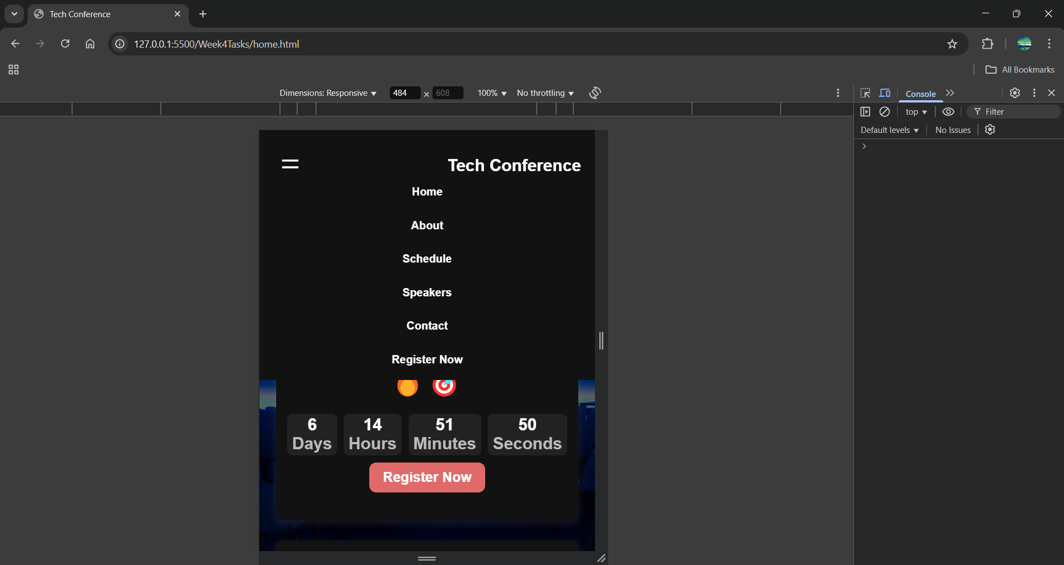

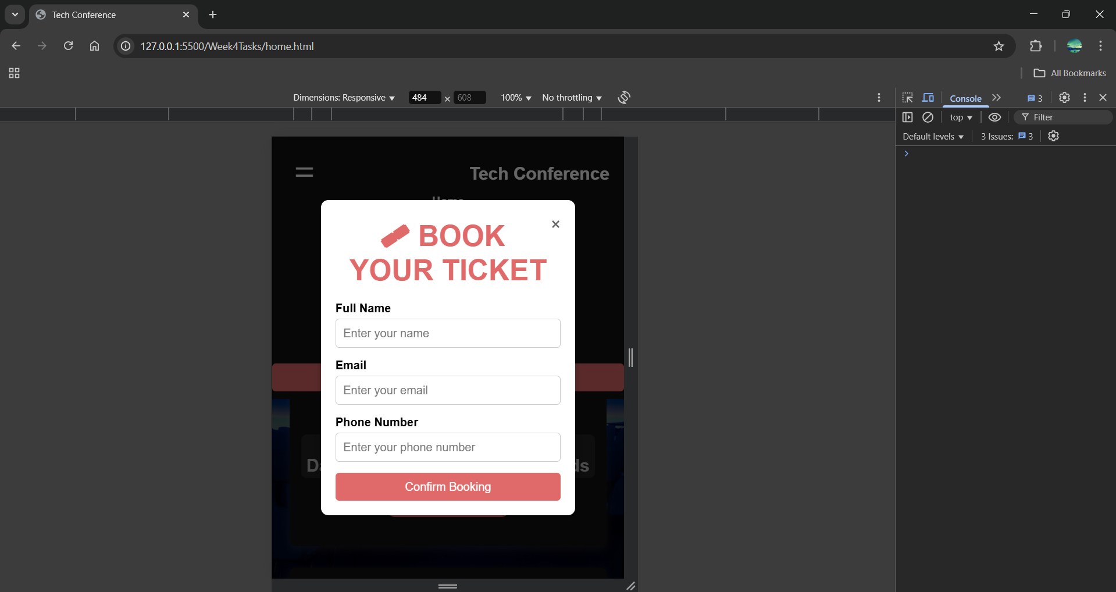

**About Page:**

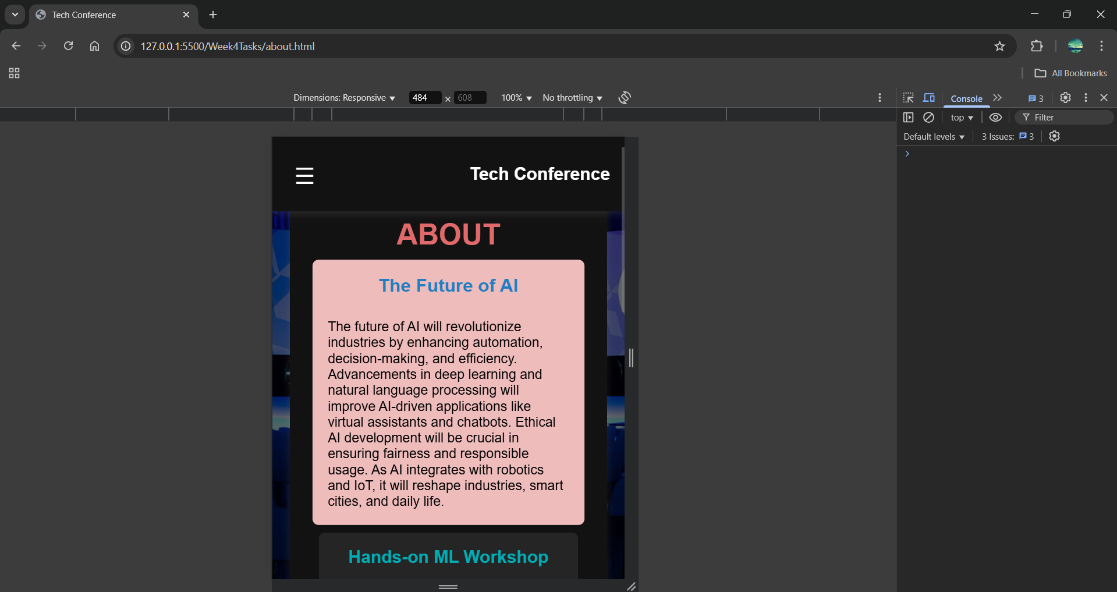

**Schedule Page:**

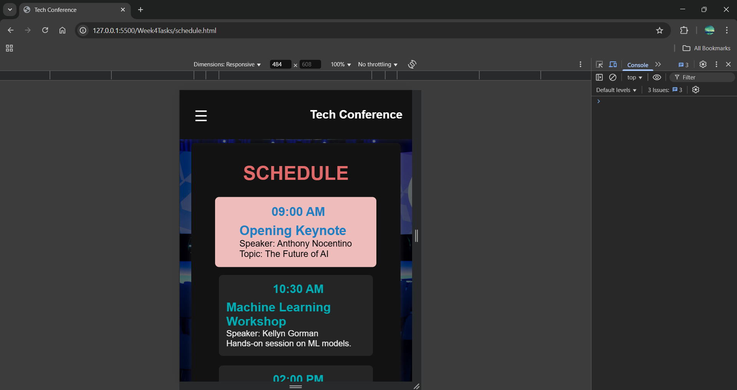

**Speakers Page:**

